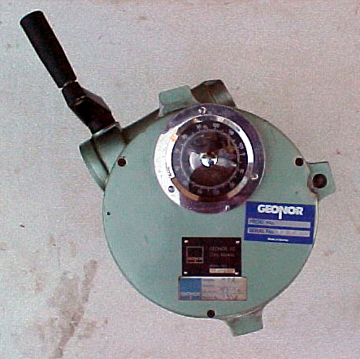**[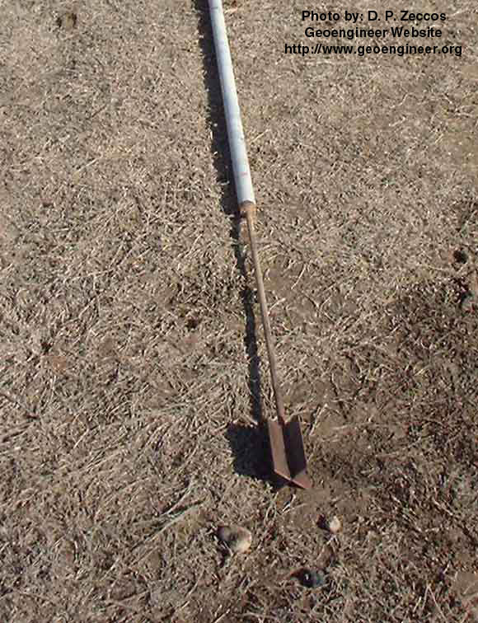](http://www.geoengineer.org/photos/vane1.jpg)VANE SHEAR**

Figure 1 :Field Vane Apparatus

Figure 2: Field Vane apparatus

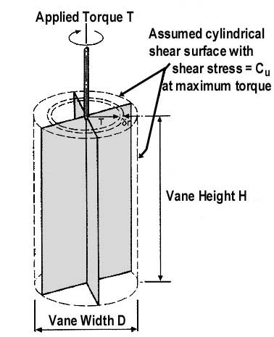

Figure 3 :Assumed Geometry of shear surface for conventional interpretation of the vane

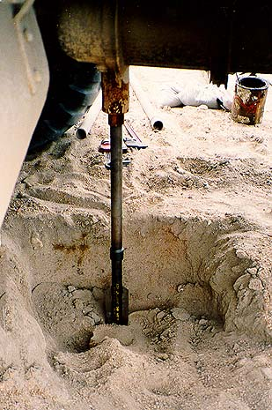

INTRODUCTION

Early geotechnical engineers found difficulty in determining the shear strength of very soft and sensitive clays by means of laboratory tests, as a result of the disturbance induced by poor-quality samplers. These difficulties let to the development of the vane shear test. This device made it possible for the first time to determine the in-situ shear strength and sensitivity of a soft clay. The vane test is routinely used only to obtain ‘undisturbed’ peak undrained shear strength, and remoulded undrained shear strength.

This test is used to estimate the undrained shear strength of a soil, and is particularly appropriate for assessing very soft and sensitive clays, which cannot be tested accurately in a laboratory as it is difficult to obtain an undisturbed sample.

A rod with a four blade vane is pushed into the ground and rotated generally at a slow rate. Once maximum torque has been reached, the vane is rotated rapidly for ten revolutions to induce shear failure. After shearing, the slow rotation rate is resumed to determine the remoulded shear strength. The shear strength is proportional to the torque / blade diameter3.

The test can be done at the base of a drillhole or trial pit, or at ground level. If the test is being conducted at the bottom of a drillhole it is important that the test area has not been disturbed by boring, generally the test is conducted five borehole diameters below the borehole base.

PROCEDURE

1. Before starting the test, the torque head measuring instrument shall be firmly secured against rotation and vertical movement with respect to ground level.
2. Push the vane slowly with a single thrust from the bottom of the borehole or protected sleeve for the distance required to ensure that it penetrates undisturbed soil. Ensure that the vane is not rotated during this stage.
3. During the execution of the test a period of 5 minutes shall be allowed to elapse between pushing the vane to its final depth and commencing rotation.
4. The torque head measuring instrument shall be zeroed before being placed over the upper extension tube.
5. Attach a torque wrench, or preferably a purpose-built geared drive unit, to the top of the vane rods, and turn the rods at a slow but continuous rate. During testing the vane shall be rotated at a rate of 8 degrees/min and readings of torque shall be record every 2 degrees rotation of the torque head. In stiffer materials which reach failure in less than 10 degrees rotation, readings shall be taken every 1 degree.
6. Once maximum torque is achieved, rotate the vane rapidly through a minimum of ten revolutions, and immediately restart shearing at the previous slow rate, to determine the remoulded strength of the soil.
7. The procedure for remoulding shall follow the requirements of MS 2038:2006
8. For both peak and remoulded tests, rotation of the vane shall be terminated when the soil has conclusively sheared or when the readings are either constant or falling for at least 20 degrees of rotation. The time to failure is generally 2 minutes to 5 minutes except in very soft clays where it may be as much as 10 minutes to 15 minutes.

NOTES

The results of a vane shear test may be influenced by many factors, namely :

1. Type of soil, especially when permeable fabric exists
2. Strength anisotropy
3. Disturbance due to insertion of the vane
4. Rate of rotation or strain rate
5. Time lapse between insertation of the vane and the beginning of the test; and
6. Progressive/instantaneous failure of the soil around the vane