**TRASH TO CASH**

Sridar Ramachandran, UPM

**ABSTRACT**

This case discusses trash issues faced by an island resort and implementation of processes that convert trash to cash. Through this case study, students will learn about the implementation process and the strategy taken by the resort management to adopt green initiative and cascading the knowledge to the community. Many issues are brought up relating to the initiative which is directly related to implementation and sustainability.

Keywords: Green Resort, recycling, clean water, environment, sustainability, waste management, strategic management, human resources management, community involvement, ecotourism.

**End of November 2014…….**

Something has not been right lately for Uncle Chang and he can’t put his finger on it. He looks across the horizon from the beach chair near his lodge. He gazed across the pristine white sandy beach to the crystal-clear water with the sun giving diamond like sparkle as the waves gently danced towards the shore. He stares on at the sea surface, counting his blessing to be able to turn his passion into his livelihood. Not many are as lucky as him, as he recalls bumping into his childhood friend, Raj, last week. Raj, an accountant at an established firm in West Malaysia, was full of complaints about his job and his life. “You are so lucky Chang, you are doing what you love, you turned your hobby into your business and you’re filling your cashbox while you play. I hardly have time for my family but you are on vacation everyday”, Raj mentioned enviously. True, Uncle Chang should be happy that his family is involved in his business but what is that nagging feeling he has been experiencing lately? As he continues to stare at the waves, his eyes caught a glimpse of a transparent floating object. “What is that? Looks like a disposable mineral water bottle. Wait, there’s another on the other side. And another…and…what??!” The whole wave was made of plastic bottles. So were the waves behind it. “What is happening?” he wondered as he moved closer to the sea. He stepped into the water, it was black not clear. Suddenly, he was pulled in, and in split second he was a few meters deep in murky water. He struggled and tried to resurface but he couldn’t. He tried to calm himself and realised that he was breathing, under water, without his diving gears. Uncle Chang looked around and in the murkiness of the water he saw a pair of sad eyes staring at him. He could make out a few more eyes approaching him. “Chang? Don’t you care about us anymore? Can’t you see we are suffering? Why didn’t you do something? You were part of us, weren’t you? You and your family, we used to play together. Why did you allow this? Why? Why? Why?” they were chanting as they surrounded him, closer and closer, squeezing him to breathlessness … Argghhh!!!

“Papa!! Wake up! What’s wrong?” Uncle Chang could hear his daughter’s concerned voice. He opened his eyes and realised he was at his house in Semporna. He must have dozed off and drifted into one of his recent recurring nightmares.

“It’s alright dear, just one of my intense dreams. I’m OK” he assured her. He looked at his daughter and continued to stare at her intently and said “No Jamilah, actually I am not OK. I am very concerned about our lodge.”

**UC’s Dive Lodge & Socio-Cultural Landscape of Mabul Island**

UC Dive Lodge is located at an island called Mabul, situated off the south-eastern coast of Sabah, East Malaysia. Mabul is managed by Tawau district and is accessible through Semporna a small town at the tip of a peninsula in Lahad Datu. It is only about 15 km away from the world-famous Sipadan and it consists of a 20-hectare piece flat land that surface not more than 3 meters above sea level.

Mabul Island (Figure 1) is a small oval shaped island in the Celebes Sea of Malaysia and placed adjacent of Sipadan. The Island has a flat terrain with a height of 2–10 m above the sea level. Mabul Island is within the Coral Triangle, an area with the highest coral diversity. Located in the district of Semporna and it is among the most famous destination among tourists (Figure 2) in Sabah and generally, the world. Before it was developed as a Centre for eco-tourism in 1980s, the island was left unattended and was only occupied by a few Bajau Laut[1] and Suluk[2] families. According to Hj Mohammad, the chairman for the Village’s Development and Security Committee of Pulau Mabul or also known as *Panglima*, the initial population at Mabul Island can be estimated between 100-130 people who were living permanently along the coast on stilt structures and about 30-50 Bajau Laut people living in boats which are known as *tempel, lanca* and *kumpit*. This group of people practised a nomadic lifestyle along the coasts of islands for economic and safety reasons, i.e. strong wind and stormy weather. Tourism development in general coupled with development restrictions imposed on nearby Sipadan Island has contributed to the fast development of Mabul as a tourism destination. Currently, there are significant numbers of high-end and budget lodges in Mabul. The rapid development also has witnessed the development of public amenities such as a primary school, mosque and police station. An increase of population as recorded in 2016 saw Mabul Island housing approximately 3000 residents. Predominantly Muslims, the ethnic composition today consists of Bajau, Bajau Laut, Bugis[3] and Suluk. The communities can be further divided into 3 groups. First, the community with proper documentation who are qualified as Malaysian citizens. The second group has the United Nations High Commissioner for Refugees (UNHCR) document to show that they have refugee status and the third group that leads a nomadic lifestyle and do not possess any documentation, hence denied recourses from public funds. Therefore, the third group are not entitled to even basic education and health benefits. This given scenario has heightened the food-water-energy-environment nexus vulnerability for the residents in Mabul Island.

Mabul is surrounded by sandy beaches and crystal-clear water, perched on the northwest corner of a larger two square kilometre reef. This paradisiacal factor has led to the emergence of a few luxury resorts as well as budget lodges, chalets and B&Bs. The island is divided to two areas, the rich side, where the resorts are located and the poor side, where the villagers live. It has been a fishing village ever since the 1970s. However, due to its proximity to Sipadan Island, it started to become popular among divers around 1990s.

Uncle Chang founded his backpackers’ style divers' lodge way back in 1999. UC Dive Lodge offered daily scuba dive and snorkel trips as well as PADI workshop & certification. They conducted all levels of SCUBA courses with good quality budget over-the-water accommodation. They also offered other specialised services such as marine safari trips to Sipadan, Kapalai, Sibuan, Mantabuan, Bohey Dulang, Maiga, Mataking, Kalapuan, Timba-Timba, Siamil and Denawan.

Their dive crew consisted of local and international PADI dive master and instructors with years of experience diving and photo hunting for intriguing marine life in Celebes Sea.

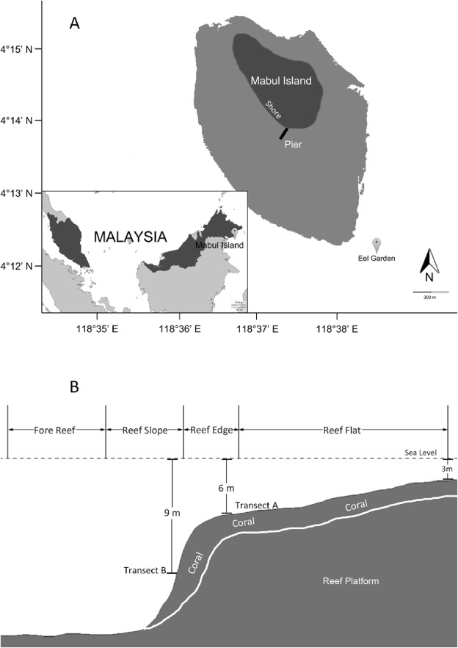

**Figure 1: Sources from L.-Y. Zhang et al. / Journal of Environmental Management 183 (2016)**

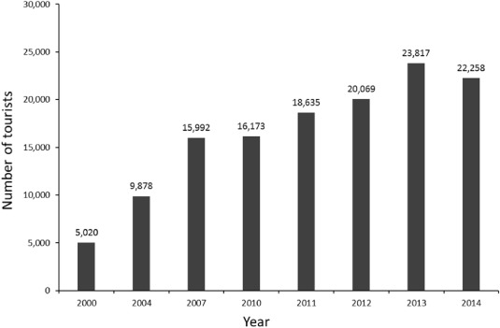

**Figure 2: Number of tourists on Mabul Island from 2000 to 2014.**

Jamilah: You’re really worrying me Papa. Lately you have become very quiet and you hardly joke around like you normally do. These recurring nightmares of yours … please tell me what are they about?

Chang: It’s nothing. I guess it is because of my subconscious distress of our surroundings and people. I was at Semporna the other day, waiting for Achik to bring our clean water supply to the jetty. There was a white boy, Australian I think, around 9 years old talking to his mother. His innocent remark caught my attention. He said “Mom, why do the people here do not bother to keep this place clean. It is filthy and it smells horrible. Don’t people use dustbins around here? Can we go somewhere else?”

Jamilah: And then?

Chang: His mother told him that they will not be staying there. He just had to bear with it for a while and soon they will be arriving at a place as good as paradise.

Jamilah: Papa, I know this issue and we have the same problem at our lodge in Mabul too. The island is also facing a similar situation. It is almost paradise at one end but at the same time, a short walk inside into the village reveals another picture. Garbage disposal and clean water supply being the main problems.

Chang: I know dear, I have always known. I have kept one eye shut all this while but I no longer can do that. There will be an influx of tourists from China soon. I have a very good rapport with the tourists and the community here. My conscience is not allowing that anymore. We need to do something, this is our problem, it is Mabul’s problem as well as Semporna….it is everyone’s problem. We need to find a way to solve this. I wish we had more support from other stakeholders’, but we can’t wait.

**Management Background & Issues**

Joe had been the Manager of the lodge for slightly over three years. Besides his experience in managing human resources and general administration matters of dive resorts, he was also a dive instructor. He assisted Jamilah in handling management related matters but most of the time he was with the clients, conducting courses or guiding divers. The lodge comprised of support staff who handled general housekeeping, kitchen, logistics and dives as well as a marketing team who were tasked to promote the lodge to the tourists. He had a few more assistants in terms of volunteers. He enjoyed his work and loved working with the father-daughter duo but his frustration with a few issues was building up. Many times he thought of leaving but something stopped him, three major blow-ups from three different clients:

“Mr Joe, we are disgusted with your management and the fact that you guys lied to us with your promises to provide clean accommodation. We just saw a rat running out from the room! Are you guys trying to kill us with rabies or what?!! We are already taking risks by coming here despite the kidnapping stories that we hear, and now this!!”

“Mr Joe, a power cut occurred again just now. This is totally unacceptable. We did not expect this kind of accommodation when we signed up with you! There was a cockroach in the bathroom too. Please do something now or refund our money!”

“I think you need to do something about that trash and stink, Mr Joe. I saw your staff fling his cigarette butt into the sea, and those garbage piles at the back, such an eyesore!”

These issues would find its way to sites such as TripAdvisor, Facebook or some blogger’s post and it was detrimental for the lodge. Joe understood their concerns and he admits that somethings can be changed but change required time and commitment from all the stakeholders. He had started an awareness and training programme with his staff on global warming, impact of human activities on the environment and the importance of recycling but his spirit has also dampened knowing that recycling efforts were not taken seriously.

Mabul particularly has clean water concerns as clean water is required for cooking, washing, cleaning wet suits, generators, shower and toilets. The, including the village people, obtained clean water from the ground which was distributed throughout the island, however, the ground water was still salty and unsuitable for cooking. It was mainly used for bathrooms and basic cleaning. Water for cooking was still brought in daily from the mainland. Some initiatives to harvest rain water had been carried out by his resort and a few others but Mabul being a small island with unpredictable rainfall pattern made rain water harvesting a less reliable source of clean water.

Every day the process of trash being produced and collected and transported out to the mainland for disposal took place. They could afford to do it and it was critical as their resort needed to be clean and beautified. The same view did not apply for the local villagers for whom the garbage was considered disposed once it was out of their courtyard. After which they considered it as not their problem anymore. They failed to see the consequences of their action leading them to turn a blind eye on the trash issue.

Joe remembered on his last job in Koh Samui, he represented his hotel and managed to witness the coming together of the local municipal, hotels, school, Tourism Department and various other stakeholders for a brainstorming session to gather opinions and to take action on how their trash issue could be tackled. It was a very fruitful session with most hotels agreeing to reduce trash by recycling and converting leftover food into organic fertilizer. He wanted to do it here, but he needed more support. He was multi-tasking as a resort manager and dive guide leaving him with very little time to start such initiatives. He knew he had to find a way.

**Intervention**

It was the 21st of January 2015, Uncle Chang, the CEO and owner of UC Dive Lodge in his Belian wood themed residence, was in deep thoughts. At the same time, around 7.30 pm, Jamilah, his daughter and the Managing Director of UC Dive Lodge was picking up a team of researchers from Universiti Putra Malaysia (UPM) at the Semporna waterfront to meet up Uncle Chang. An hour later she walked in with two gentlemen and a lady. Jamilah introduced them as researchers from UPM who were conducting a few studies in Semporna.

Chang: Welcome Professors, Doctors from UPM. I hope you had a good journey. Come, join us for dinner and let me tell you a little bit about myself.

Prof AS: Thank you Uncle Chang for inviting us today and for your kind hospitality. Tell us, what is your story?

Chang: I was born in Semporna. At this moment, as you can see, I have everything. I am considered a legend here, but I started very poor … just driving a lorry for a living. At times I just mixed plain rice with cooking oil to feed my children. I am grateful to God because now all my children are educated and I am a successful local dive lodge entrepreneur. I got to know from Jamilah that UPM has been doing research in Semporna now for a few years.

Dr Siow: You are right. We have been doing research in Semporna since 2011. Our research is about tourism and environment which is funded by the Ministry of Higher Education.

Prof AS: We have students doing research in tourism economy, tourism enterprise, tourism and waste management, tourism policy and tourism management in Semporna.

Chang: That is wonderful. We are really glad that that you considered Semporna for your study site. Let me tell you what is in my mind and why I was very excited about this meeting today. I have been constantly worried and thinking for very long about my dive lodge. I am concerned about Mabul, Semporna and my dive lodge. I have spent a lot of money to organise clean Mabul and clean the environment programmes. I have also given one of the Malaysian Environmental NGO money to do some cleaning work. But it was not very successful until now. I am Semporna born. I want to do something for Semporna. Major problem here is waste. It is making the place dirty and is also increasing my operational costs to transport waste. Another issue I want to highlight in Mabul is shortage of water. We need to transport clean water daily to Mabul Island for tourist consumption and to wash dive gears and suits.

Dr Sri: Uncle Chang, thank you for sharing your concerns about Mabul Island and your business operations. We will discuss with our research team on how to make your Dive Lodge a green resort. We will need your support to do more research and come up with suggestions on the green initiatives that we can introduce. Give us a few weeks to work on the proposal and we will have another meeting.

Chang: Thank you. You have all my support. You know, if the environment is not clean and attractive, tourists will stop coming. And without tourists we don’t have business. But above all, it is not just about tourist and business. I grew up here and I know how the surrounding has changed over the years. I feel extremely sad looking at the environment, sea and the marine life. I hope UPM can help on this matter fast before we lose the beauty of this place. Tomorrow we will visit Mabul and I will personally show you the island, the issues that we are concerned about and introduce you to some of our staff.

Dr Siow: Thank you uncle Chang. That will be a good start for us to work on our research proposal.

**Go Green Initiative**

Slightly more than a year has passed since the first meeting between Chang and the researchers from UPM. Communications have taken place, letters going to and fro, grants applied and approved. The green initiative partnership was gaining momentum. This collaboration resulted in the UPM team securing a Knowledge Transfer Programme grant from the Ministry of Higher Education (MOHE). This Go-Green initiative with the main title being “Introducing sustainable and innovative green entrepreneurship by turning trash to cash” has started and a graduate intern has been permanently positioned at the lodge to drive the initiatives for this program.

Waste Separation

Waste has started to be separated to a few categories. There were inorganic recyclable waste products such as aluminium cans, glass and plastics which were non-biodegradable therefore could either be reused or recycled. Most of them were sent for recycling but some bottles were cut and creatively reused as planting pots around the resort. Dry organic waste and biodegradable products such as papers and cardboards were also sent for recycling and they too were separated in allocated bins with clear signage indicating the right bin for the right type of waste. Every week the waste were brought to the mainland Semporna and sent to recycling centres.

Kitchen organic wastes such as vegetable peels, seeds, meat waste were also collected as well as food waste, generated from leftover of clients and staffs plates. These waste products could be useful for composting however the initiative to convert them to organic fertilizers had not started successfully at this point of time. Therefore, these wastes were just collected and sent to the mainland to be disposed accordingly as normal domestic waste.

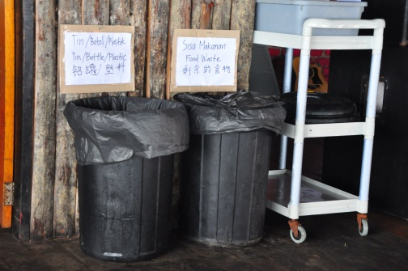

Water collection

Rain water harvesting was still going on but the amount was highly unpredictable. However, the more successful part of this project was the water collection from the lodges’ air-conditioning units. Uncle Chang had eight units of air-conditioners. A collection of plastic bottle was placed at the end of the water pipe that allowed the air-conditioned water produced from condensation to flow out. The record showed that the total amount of water collected from all eight units summed up to an average of 580 Litres of water each week. This water has been used for dive suit washing, cleaning the bathrooms and toilets as well as watering plants.

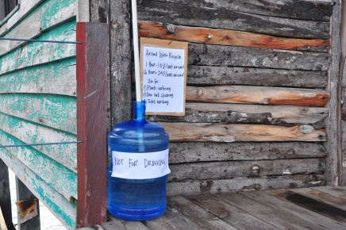

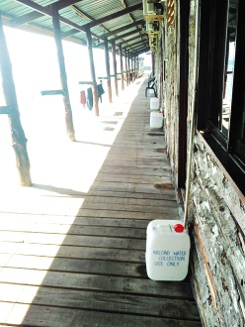

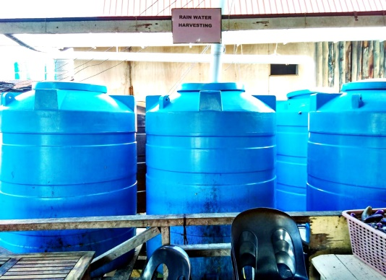

A soft launch was carried out to create awareness amongst the dive lodge workers in January 2016 that received good media coverage and was well received by the lodge employees. The full launch of this programme also took place, gaining media attention as well as popularity amongst employees of the lodge as well as tourists and community members in Mabul.

**Epilogue**

Joe had just finished his dive session with a group of tourists from Johor and Singapore. They were very happy with their dive but Joe wasn’t. There were lesser corals lately, coral bleaching is happening and it was difficult to sight even a single black tip shark or manta ray these days. As he cleaned his gears in the water collected from the air-conditioner outlet, he noticed Chang in deep conversation with what looked like an unhappy client. He left his gear and started to walk towards them. He was now able to catch the conversation.

“Mr Chang, I am so sad with the condition of this island. We took a stroll yesterday evening and saw a soiled diaper in the sea. And that trash piled up at the back, I am sure I saw a huge rat in it. Where is the awareness of everyone? Very disappointing really! Let me ask you something Mr Chang. If you were to visit an exotic location and given a room with strikingly beautiful scenery, but the rest of the area is a dumpster, would you be happy there?”

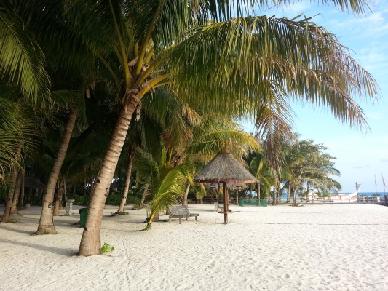

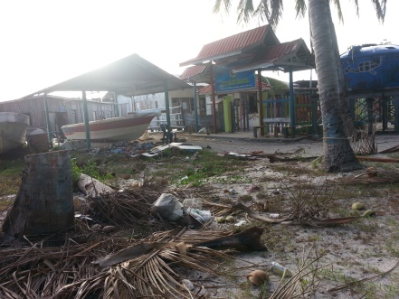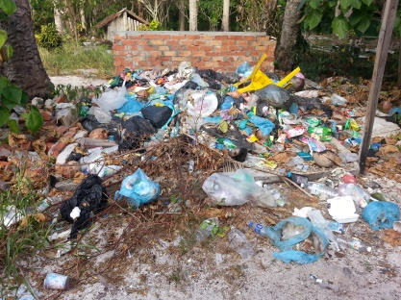

Chang was left dumbstruck and was only able to stare as his client walked away to his room. He turned to Joe, who was equally dazed and said “What went wrong Joe? I thought we are on the right track. What do we do now?”

1. People of the south-western Philippines and Indonesia live their entire lives on the sea, also known as “Sea Gypsies” or “Sea Nomads”
2. The Suluk or Tausūg people are an ethnic group of the Philippines and Malaysia.
3. An ethnic group of South Sulawesi, Indonesia.